Meeting 1/8/2020

Base

* Graphics on Plywood: TI, EE emerge, COE, Group name: FourFace
* Graphics on Acrylic: names? designs?
* Face (plywood)
  + 4 layers: 2 (1/4in), 1 (1/2 in), 1 (1/8in)
  + 4 faces: 8 (1/4in), 4 (½ in), 4 (1/8in)
  + (14x14in) x 4layers x 4faces cut out of 2x3ft plywood sheets (less waste)
  + 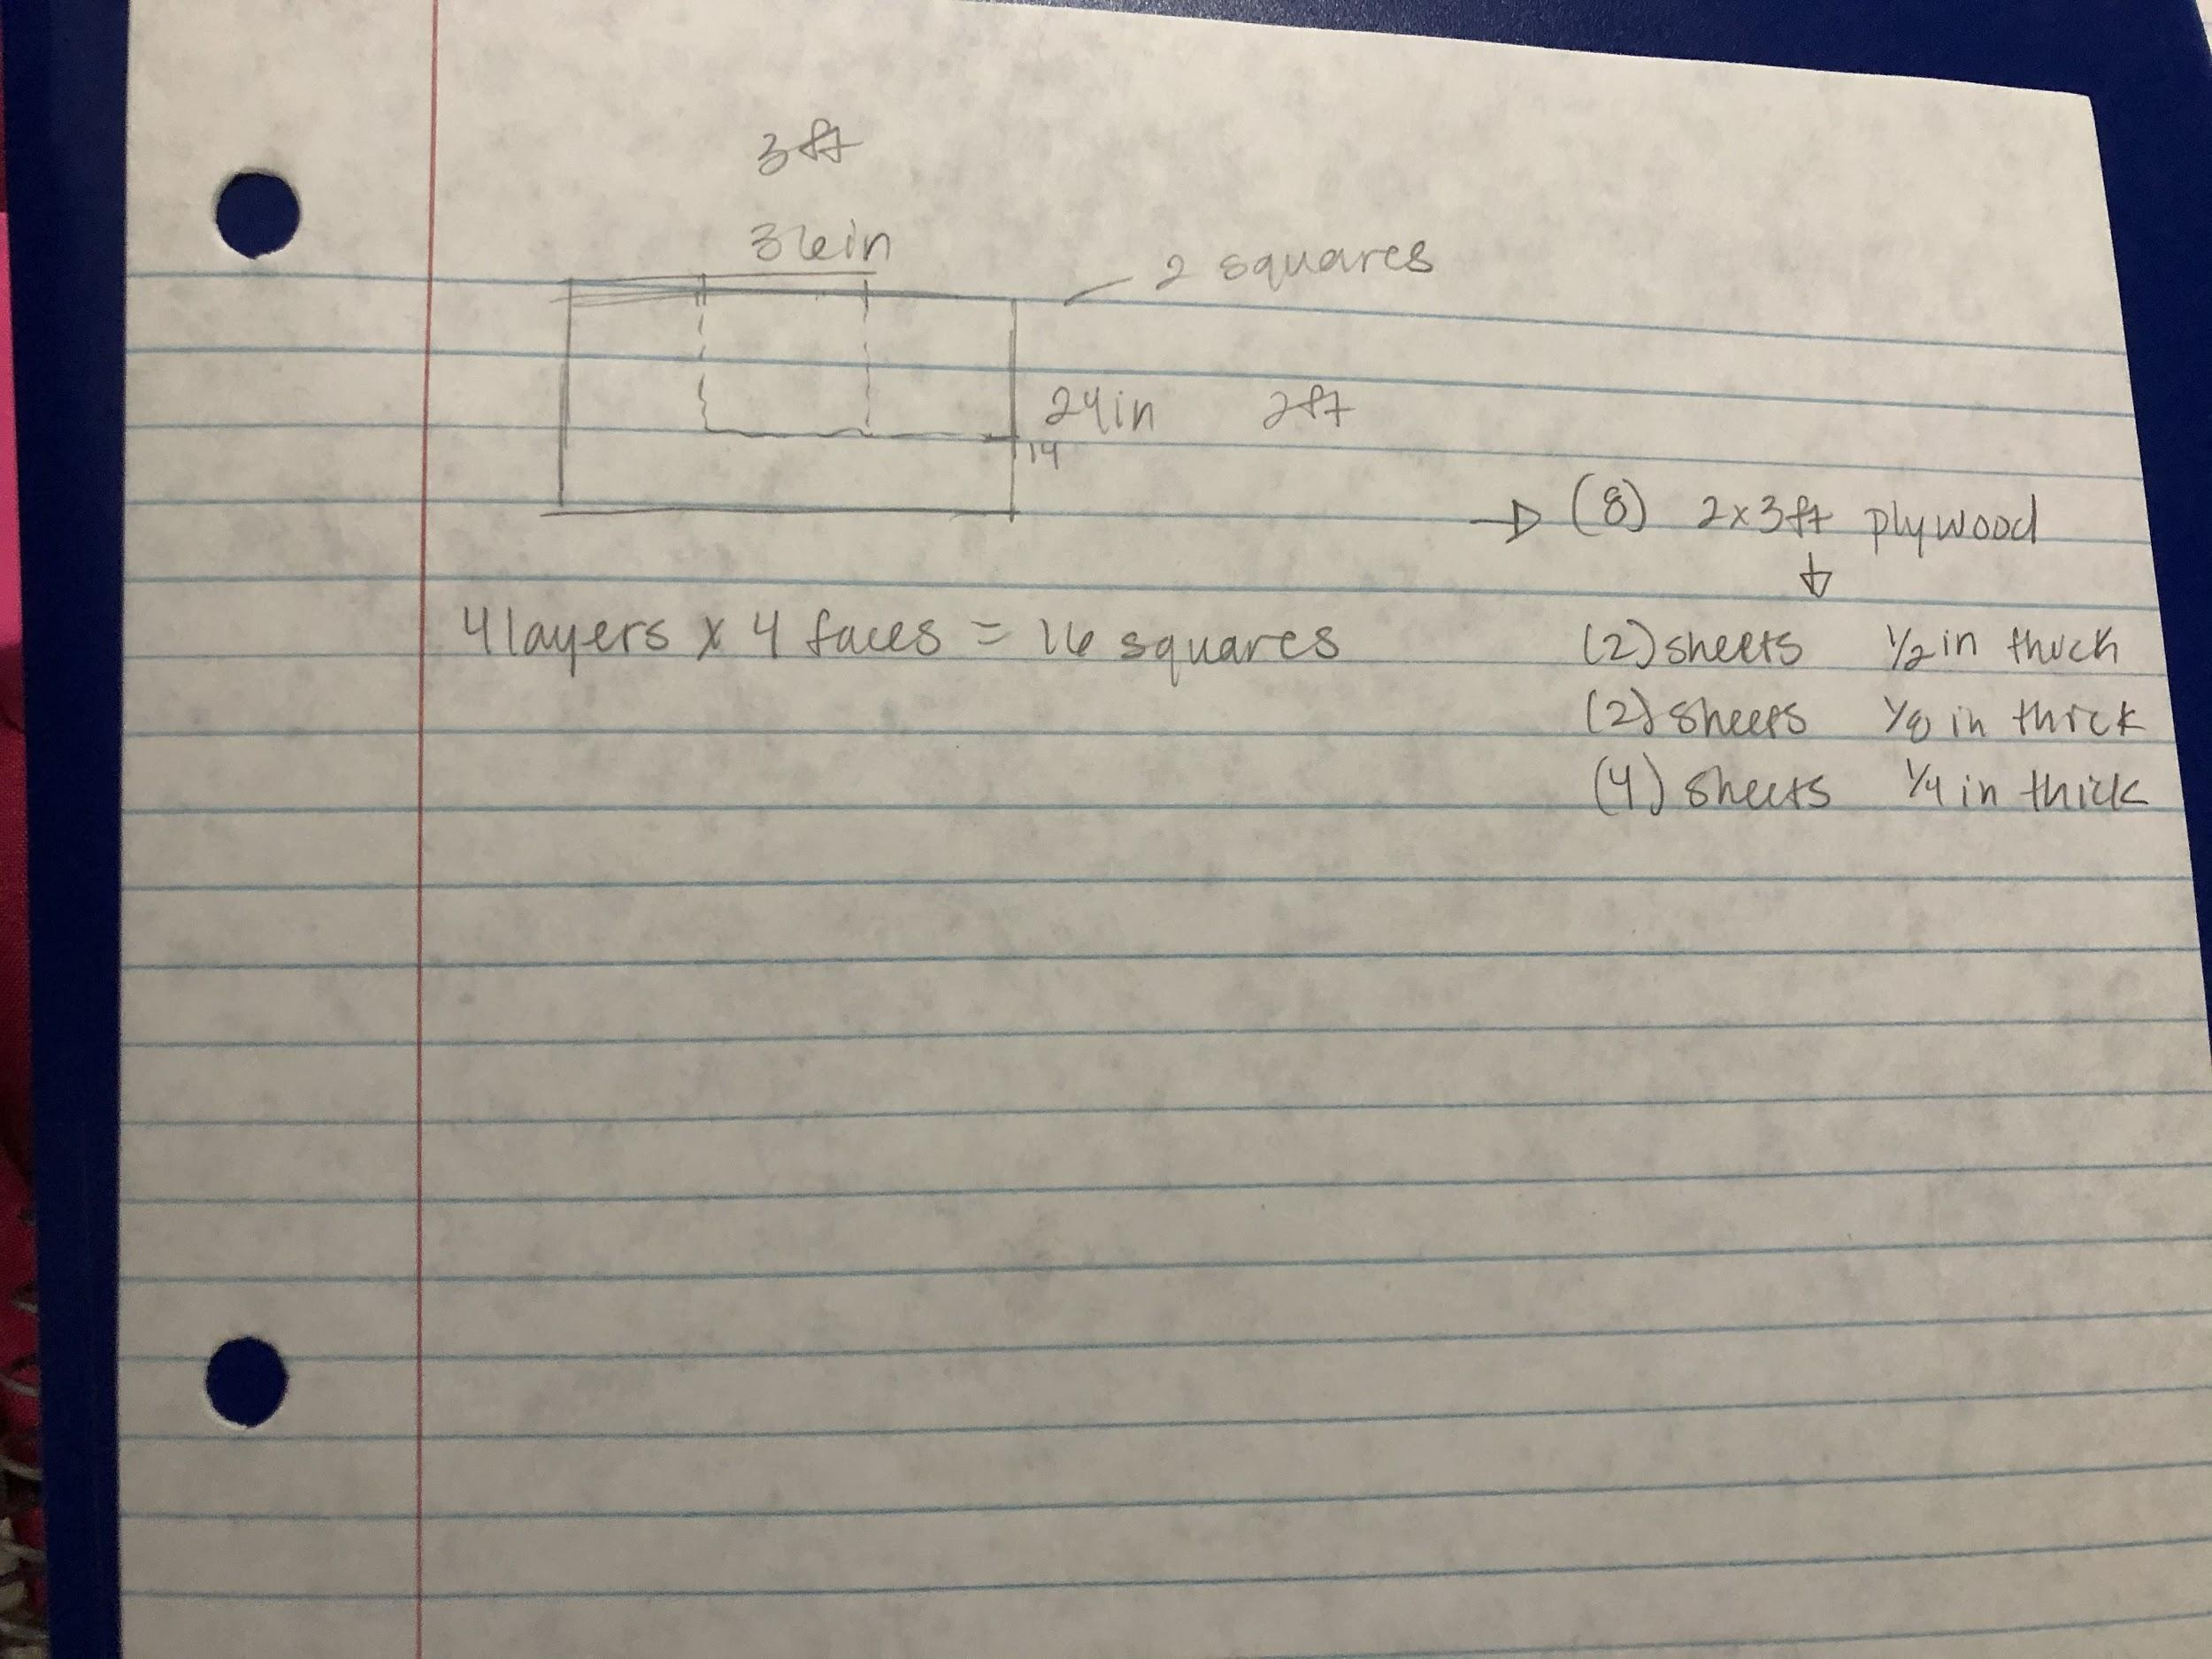

TO DO:

* 3D model
* Cap sense w acrylic
* Get acrylic
* Laser cutting

|  |  |
| --- | --- |
| Week 1 | Finish 3D model  Cap touch sense  Order: (can reference budget sheet)  acrylic  Get plywood (find out how much we actually need to buy)  Jumper wires  LEDs  Send graphics to be laser cut on base |
|  |  |